Invitation to Quote (ITQ)

Shopping for: Supply and installation of furniture

Project Title: Fruit Garden Project (EIB financed).
Contracting Authority: Consolidated Unit for Implementing & Monitoring the Wine Sector Restructuring Program (UCIMPRSVV).

Date: August 22, 2025
ITQ No: FURN_SVETLAI_2025

In attention: Furniture suppliers

Dear Bidders,
you are invited to submit your bids (at 0% VAT rate) regarding Supply and installation of furniture for the endowment of the newly built Laboratory of horticultural products processing and agricultural equipment maintenance within Technical Agricultural College from Svetlii, Republic of Moldova, procured within the INVESTMENTS IN INFRASTRUCTURE Component of the “Fruit Garden of Moldova” Project.

You are requested to bid for 100% of listed items.
The following goods are necessary to be supplied and installed:

No | Specificatii minime solicitate | Imagine simbol (exemplu) | Cantitate
1 | Masă pentru elevi  L1400*A680*H750  Blat PAL melaminat 36 mm,  Culoare Sonoma 3025  Finisaj exterior: sonoma/blat lemn + picioare (negru metalic) | 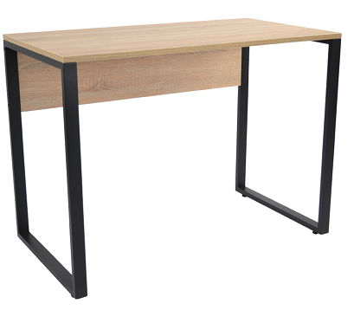 | 16 buc
2 | Masă de birou  L1380*A600*H750  Blat din PAL melaminat,  Grosime 18 mm  Culoare: stejar Riviera / gri închis  Cadru metalic vopsit, cu picioare pătrate | 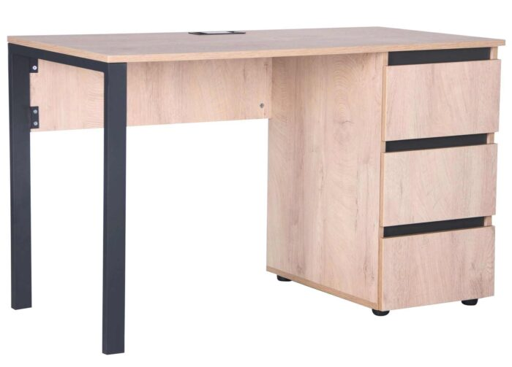 | 2 buc
3 | Scaun  Înălțime totală: 820 mm  Lățime/Adâncime scaun: 470 × 470 mm  Șezut: 460 × 470 mm  Spătar din plasă și șezut tapițat în stofă, culoare gri  Cadru metalic cromat  Capacitate maximă: 120 kg | 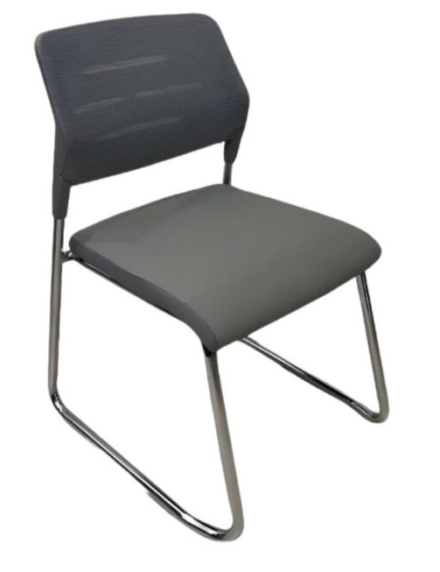 | 34 buc
4 | Canapea  Lungime total – 1950 mm  Spațiu pentru șezut – 1800 mm  Adâncime de 850 mm  Corp placaj și spumă poliuretanică  Carcasa – metal vopsit în câmp electrostatic, culoare antracit  Tapițare cu piele eco  Culoare tapiterie: negru | 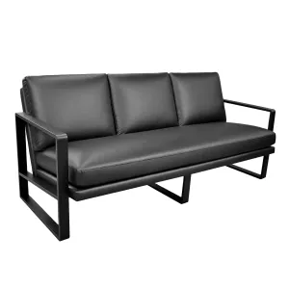 | 2 buc
Furnizorul, de comun acord cu Cumpărătorul, va coordona cu Beneficiarul final (Colegiul Svetlâi) culorile/ nuanțele finale și amplasarea exactă a mobilierului.
Livrarea completa (transportare, descarcare, montare) și instalarea integrala a tuturor pieselor de mobilier și accesoriilor va fi efectuata de către Furnizor și vor fi incluse în prețul bunurilor. Termen de garanție- 12 luni.

2. You must bid for all the items under this tender. Bids will be evaluated for all the items requested and contract(s) awarded to the Bidder offering the lowest evaluated total cost of all the requested items.
Incomplete (on list items and/or quantities and/or adjacent installation services) bids shall be disqualified. The contracting Authority reserves the right to contract and modify the original quantities by +/- 25% (referring to total original volumes, or certain technical services).

3. Your bid, in the form attached (Attachments 1 to this ITQ) must be submitted in a sealed envelope at the following address:
Consolidated Unit for Implementing & Monitoring the Wine Sector Restructuring Program (UCIMPRSVV)
18, Calea Basarabiei, 2nd floor (yellow building),
Chisinau, Republic of Moldova, MD-2023
Attn: Radu Voicu, Interim Executive Director of UCIMPRSVV

4. Your quotation in English or Romanian language, should be accompanied by adequate detailed technical information for each item quoted.

5. The deadline for receipt of your bid by the Purchaser at the address indicated in Paragraph 3 is: hour 10:00 AM, August 14, 2025.

6. Bids by fax or by electronic means are not acceptable.

7. Your bid should be submitted as per the following instructions and in accordance with the attached Contract (for Contract Form see Attachment 2 to this ITQ).

(i) PRICES: Prices will be quoted in MDL/EUR.
(ii) EVALUATION OF BIDS: Offers determined to be substantially responsive to the technical specifications will be evaluated by comparison of their prices by converting their price to the Moldovan Leu (MDL) based on the official exchange rate published by the National Bank of Moldova on the date specified in Paragraph 5 of this invitation for submission of quotations.
In evaluating the quotations, the Purchaser will determine for each proposal the evaluated price by adjusting the price quotation by making any correction for any arithmetical errors as follows:
(a) where there is a discrepancy between amounts in figures and in words, the amount in words will govern;
(b) where is a discrepancy between the unit rate and the line item total resulting from multiplying the unit rate by the quantity, the unit rate as quoted will govern;
If a Supplier refuses to accept the correction, its bid will be rejected.

(iii) AWARD OF CONTRACT: The award will be made to the bidder offering the lowest evaluated price and that meets the required standards of technical and financial capabilities. The successful bidder will sign a Contract as per attached form of contract and terms and conditions of supply/performance.

(iv) VALIDITY OF THE OFFER: Your quotation(s) should be valid for a period of sixty (60) days from the deadline for receipt of bid indicated in Paragraph 5 of this ITQ.

8. Further information can be obtained from:
PIU Procurement Department,
Consolidated Unit for Implementing & Monitoring the Wine Sector Restructuring Program (UCIMPRSVV) office@winemoldova.md
Office phone: (+373) 22 260906, (+373) 78812211;

9. Please Confirm by E-mail indicated above - the receipt of this invitation and whether or not you will submit the price quotation(s).

10. The prices quoted by the Bidder shall not be subject to adjustment during the performance of the Contract. Note: The services and services that are procured under Finance Contract no (Serapis) 2014-0041, signed between the Government of the Republic of Moldova and the European Investment Bank, are free of import taxes, VAT and payment of customs duties according to Government of Moldova Decision nr. 246 from 08 April 2010 (Published in the official gazette Monitorul Oficial al Republicii Moldova, from 2017, nr. 73-77 art.195).

11. Limitation of damages/loss:
This ITQ does not constitute an offer. No agreement shall result upon submission of proposals/bids. The Project/Contracting Authority SHALL NOT BE UNDER ANY OBLIGATION TO ENTER INTO ANY AGREEMENT WITH ANYONE IN CONNECTION WITH THIS ITQ unless the Project/Contracting Authority executes and delivers an agreement in writing approved by the Project/Contracting Authority.

By submitting a proposal, the Bidder agrees that in no event will the Bidder claim damages in excess of an amount equivalent to the reasonable costs incurred by the Bidder in preparing its proposal for matters relating to any agreement or concerning the competitive process, and, the Bidder, by submitting a proposal, waives any claim for loss of profits if no agreement is made with the Bidder.

The Project/Contracting Authority reserves the right to reject any and all bids (including the lowest cost proposal); The Project/Contracting Authority reserves the right to cancel this tender at any time for any reasons (with or without commencing a new tender process in its place).

Sincerely,

Radu VOICU
UCIMPRSVV Executive Director

Attachment 1.
ITQ No: # FURN_SVETLAI_2025
{a fi inclus antetul companiei/ofertantului }

Terms and Conditions of Supply

Project Name: Fruit Garden of Moldova
Contracting Authority/Purchaser: Consolidated Unit for Implementing & Monitoring the Wine Sector Restructuring Program (UCIMPRSVV)

Dear Sirs,
As per your ITQ # FURN_SVETLAI_2025, we are pleased to submit the present
Bid as follows:

1. Prices and Schedules for Delivery:

Nr d/o |  | Description | Quantity,  units | Price unit, [currency] | Total sum,  [currency]
1 |  | Masă pentru elevi L1400*A680*H750 | 16 buc
2 |  | Masă de birou L1380*A600*H750 | 2 buc
3 |  | Scaun | 34 buc
4 |  | Canapea | 2 buc
Livrarea completa (transportare, descarcare, montare) și instalarea integrala a tuturor pieselor de mobilier și accesoriilor va fi efectuata de către Furnizor și vor fi incluse în prețul bunurilor. Termen de garanție- 12 luni.
Furnizorul, de comun acord cu Cumpărătorul, va coordona cu Beneficiarul final (Colegiul Svetlâi) culorile/ nuanțele finale și amplasarea exactă a mobilierului.
 | TOTAL Bid PRICE (currency / valuta)
Note: In case of discrepancy between unit price and Total derived from unit price, unit price shall prevail.
All prices must be indicated 0% VAT and free of any other taxes.

2. Fixed Price The prices indicated above are firm and fixed and not subject to any adjustment during contract performance. Final order amounts/quantities may be adjusted by Purchaser with +/-25%.
3. Delivery Schedule: The delivery and installation should be completed within 20 working days since the date of contract signing. Note: all auxiliary materials procured shall be new, and never used before.
4. Payment For local Suppliers (residents of Moldova), payment for Services and Services shall be made in MD Lei. Payment will be made within maximum 20 working days, after receiving the fiscal bill.

5. Warranty: 12 months;

- Delivery, Packaging and Marking Instructions:
The Supplier shall transport the contracted goods to the final beneficiary location. Such services, are included in the price of the services according to ItQ. More details are indicated in Attachment 1.

- Failure to Perform: The Purchaser may cancel the Contract if the Supplier fails to deliver the Services and Services, in accordance with the above terms and conditions, in spite of a 21 day notice given by the Purchaser, without incurring any liability to the Supplier.

- Covenant of Integrity to UCIMPRSVV from the Bidder/Supplier:

“We declare and covenant that neither we nor anyone, including any of our directors, employees, agents, joint venture partners or sub-contractors, where these exist, acting on our behalf with due authority or with our knowledge or consent, or facilitated by us, has engaged, or will engage, in any Prohibited Conduct (as defined below) in connection with the tendering process or in the execution or supply of any works, services or services for procurement # FURN_SVETLAI_2025 (the “Contract”) and covenant to so inform you if any instance of any such Prohibited Conduct shall come to the attention of any person in our organization having responsibility for ensuring compliance with this Covenant.

We shall, for the duration of the tender process and, if we are successful in our tender, for the duration of the Contract, appoint and maintain in office an officer, who shall be a person reasonably satisfactory to you and to whom you shall have full and immediate access, having the duty, and the necessary powers, to ensure compliance with this Covenant.

We declare and covenant that neither we nor anyone, including any of our directors, employees, agents, joint venture partners or sub-contractors, where these exist, acting on our behalf with due authority or with our knowledge or consent, or facilitated by us, (i) is listed or otherwise subject to EU/UN Sanctions and (ii) in connection with the execution or supply of
any works, services or services for the Contract, will act in contravention of EU/UN Sanctions.

We covenant to so inform you if any instance shall come to the attention of any person in our organization having responsibility for ensuring compliance with this Covenant. If (i) we have been, or any such director, employee, agent or joint venture partner, where this exists, acting as aforesaid has been, convicted in any court or sanctioned by any authority of
any offence involving a Prohibited Conduct in connection with any tendering process or provision of works, services or services during the five years immediately preceding the date of this Covenant, or (ii) any such director, employee, agent or a representative of a joint venture partner, where this exists, has been dismissed or has resigned from any employment on the
grounds of being implicated in any Prohibited Conduct, or (iii) we have been, or any of our directors, employees, agents or joint venture partners, where these exist, acting as aforesaid has been excluded or otherwise sanctioned by the EU Institutions or any major Multi-lateral Development Bank (including World Bank Group, African Development Bank, Asian
Development Bank, European Bank for Reconstruction and Development, European Investment Bank or Inter-American Development Bank) from participation in a tendering procedure on the grounds of Prohibited Conduct, we give details of that conviction, dismissal or resignation, or exclusion below, together with details of the measures that we have taken,
or shall take, to ensure that neither this company nor any of our directors, employees or agents commits any Prohibited Conduct in connection with the Contract [give details if necessary].

We acknowledge that if we are subject to an exclusion decision by the European Investment Bank (EIB), we will not be eligible to be awarded a contract to be financed by the EIB. We grant the Fruit Garden Project (UCIMPRSVV – PIU), the European Investment Bank and auditors appointed by either of them, as well as any authority or European Union institution or body having competence under European Union law, the right to inspect and copy our books and records and those of all our sub-contractors under the Contract. We accept to preserve these books and records generally in accordance with applicable law but in any case for at least six years from the date of tender submission and in the event we are awarded the Contract, at least six years from the date of substantial performance of the Contract.”

NAME OF THE SUPPLIER____________________________________________________

Authorized Signature__________________________________________________________

Place: Date:

Attachment 2.
ITQ # FURN_SVETLAI_2025

{model} CONTRACT

Contract Nr. FURN_SVETLAI_2025 Data:________________, 2025

Numele ofertantului:
Cod fiscal, adresa, tel, email:
Reprezentată de ……………… “FURNIZOR”, pe de o parte,
și
„Unitatea Consolidată pentru Implementarea şi Monitorizarea Programului de
Restructurare a Sectorului Vitivinicol” (UCIMPRSVV)
Adresa juridică: or. Chișinău, bd. Ștefan cel Mare și Sfânt 162
Tel: (+373) 22 260906; (+373) 078812200, Email: office@winemoldova.md
Reprezentată de Radu Voicu, Director Executiv interimar,
“CUMPĂRĂTOR”, pe de altă parte, au încheiat următorul contract:

1. SUBIECTUL CONTRACTULUI
FURNIZORUL se angajează să presteze şi Cumpărătorul se angajează să procure Bunurile indicate în specificaţiile Contractului „BUNURILE” (Anexa 1) în termenii şi condiţiile stipulate de prezentul Contract. Acest contract (inclusive termenul de garanție) este valabil până la 31.08.2026.

2. CALITATEA BUNURILOR
Calitatea BUNURILE trebuie să corespundă Specificaţiilor Tehnice indicate în Anexa 1 si Anexa 2 a prezentului Contract.

- PREŢUL CONTRACTULUI
3.1. Preţurile Bunurilor sunt stabilite în {valuta} şi indicate în specificaţia Contractului.
3.2. Suma totală a Contractului este {suma}.

- TERMENII ŞI CONDIŢIILE DE LIVRARE
4.1 FURNIZORUL va livra BUNURILE și Bunurile incidente în termeni conform Anexa 1. Livrarea/prestarea se face la adresa/beneficiar final:
- Colegiul Tehnic Agricol din Svetlâi, str. Lenin 22, com. Svetlâi, Comrat.

4.2 BUNURILELE vor fi însoţite de următoarele documente:
- Act(e) primire-prestare;
- Factura, semnată şi ştampilată;
- Certificat de garanție pentru bunurile livrate (12 luni din data livrării și instalării);

4.3 Dacă termenii de livrare nu sunt respectaţi, FURNIZORUL va plăti pagubele în mărime de 0.5% din preţul fiecărei unităţi a BUNURILOR nelivrate, pentru fiecare zi de întârziere şi până la 10 % din suma Contractului stabilită în p. 3.2 mai sus.

5. PLATA
CUMPĂRĂTORUL efectuează plata pentru „BUNURI” (Anexa 1), in MDL la rata oficiala de schimb EUR/MDL stabilită de către Bancă Naționala a Moldovei la ziua eliberarii facturii fiscale, in modul următor:
- 20% (douazeci procente) din suma contractului, avans, în termen de 20 zile lucrătoare, la solicitarea Furnizorului, în baza Contului de plata / Invoice emis de Furnizor;
- 80% (optzeci procente) din suma bunurilor livrate (confirmat prin Act de predare primire a bunurilor livrate și de acceptare a calității tuturor bunurilor si serviciilor adiacente livrate/prestate de Furnizor, semnat de Cumpărător, Beneficiarul Final si Furnizor), în termen de 20 zile lucrătoare, in baza facturii fiscale eliberate de către FURNIZOR;

6. CONDIŢIILE ACCEPTĂRII BUNURILE
Acceptarea în cazul prezentului Contract înseamnă prezentarea de către FURNIZOR a unui set complet de documente de expediţie şi a unui protocol de acceptare din partea CUMPĂRĂTORULUI. Orice costuri la care va fi supus CUMPĂRĂTORUL din cauza documentelor incorecte remise de FURNIZOR, se vor face din contul celui din urmă.

7. ARBITRARE
7.1 Toate disputele care pot să apară în legătură cu prezentul Contract vor fi aplanate prin negocieri de către Părţile implicate.
7.2 Dacă Părţile nu pot soluţiona disputa sau neînţelegerile din timpul negocierilor, atunci aşa dispută va fi adresată pentru analiză şi aplanare instantei de judecata, in conformitate cu legislatia Rep. Moldova.
7.3 Acest Contract se va supune legilor Republicii Moldova.

8. FORŢELE MAJORE
Parțile se scutesc de răspundere pentru ne-îndeplinirea parţiala sau totala a obligaţiilor conform prezentului Contract daca a intervenit o forţa majora : avarie, incendiu, inundaţii sau cutremur de pământ, război, acte nelegitime ale terţelor persoane in funcţii, intrarea in vigoare a actelor legale de interzicere directa sau indirecta a activităţilor, ce pot împiedica derularea prezentului Contract, ce pot provoca in general lichidarea Părţilor ca persoane juridice sau a altor circumstanţe ce au apărut după semnarea prezentului Contract ce nu depind de buna voinţa a Părţilor. In acest caz termenii de îndeplinire a obligaţiilor conform prezentului Contract se vor deplasa proporţional timpului pe parcursul căruia au existat forte majore. În caz ca aceste circumstanţe funcţionează mai mult de 3 (trei) luni, părţile au dreptul de a rezilia prezentul Contract si nici una din Părţi nu va avea dreptul de a cere careva compensaţii pentru pierderi de la Partea opusa. Faptul de intervenire sau dispariţie a situaţiei Forţele Majore se va confirma de un act legal emis de un organ autorizat de stat.

9 ALŢI TERMENI ŞI CONDIŢII
9.1 Orice schimbări sau amendamente la prezentul Contract vor intra în forţă doar când vor fi făcute în formă scrisă şi semnate de reprezentanţi autorizaţi ai ambelor Părţi. Toate amendamentele şi anexele constituie o parte integrantă a prezentului Contract, în cazul în care sunt făcute în formă corectă.
9.2 Dacă se consemnează de ambele Părţi, un item din Anexa 1 poate fi înlocuit de un altul egal sau mai ieftin decât cel care se înlocuieşte, cu condiţia că acesta este echivalent din punct de vedere tehnic sau chiar superior celui înlocuit.
9.3 Prezentul Contract este făcut în două originale identice în limba romana.
9.4 Contractul intră în vigoare din data semnării lui de către Părţi, şi este valid până la sfârşitul tuturor condiţiilor de garanţie, de plată sau a celor stipulate de prezentul Contract. Termenii Contractului pot fi prelungiţi, stopaţi pentru o perioadă de timp sau chiar anulaţi în baza unui acord mutual al Părţilor.
9.5 Prezentul Contract este compus din următoarele documente:
- Contractul dat;
- Specificaţiile prezentului Contract (Anexa 1);
FURNIZOR:  ADRESA:  Tel.  Email:  Cod fiscal:  IBAN:  Numele băncii:  Adresa băncii:  Codul băncii:  Furnizor | Cumparatorul:  Unitatea consolidata pentru implementarea şi monitorizarea Programului de restructurare a sectorului vitivinicol” (UCIMPRSVV)  Adresa juridica: bd. Stefan cel Mare 162  Cod fiscal: 1010601000302  Banca: MF-TR Chisinau-bugetul de stat  IBAN: _______________________________  Furnizorul platitor: MF-Trezoreria de Stat  Codul bancii: TREZMD2X  Radu Voicu  Director Executiv interimar __________________
Anexa 1 la Contractul Nr. # FURN_SVETLAI_2025

Livrabile / Specificații Tehnice

(se va anexa copia ofertei)

